

**Contractual Information**

**HR Guide**

**Contractual Information – HR Guide**

# Introduction

This guide covers a range of contractual information which includes:

* Contract of employment
* Contractual terms
* Employee handbook
* Secondments at work
* Assignment abroad
* Par-time workers
* Fixed term contracts
* Breach of contract
* Statutory rights at work
* Continuity of employment
* Calculating continuous employment
* Moving from one employers to another
* Changes to terms and conditions of employment
* Confidential information
* Intellectual property rights
* Restrictive covenants
* Whistle blowing

# Contract of Employment

A contract of employment is an agreement between an employer and employee and is the basis of the employment relationship. There is no statutory requirement to have a written contract of employment in its entirety but employers are required by law to provide certain written particulars of the terms and conditions of the contract to the employee. This is known as a Written Statement of Particulars. It is therefore common practice to have a written statement issued to all employees to include all of this information. The right to section 1 statement extends to workers from 6th April 2020

**This written statement must include the following:**

* Identity of the parties
* Date of commencement of the contract
* Date of commencement of continuous employment
* Job title or brief description of the job duties
* Notice periods
* Expected duration of the contract • Place of work
* Hours of work, including overtime
* Rate of pay
* Frequency of pay
* Holiday entitlements and holiday pay
* Sickness provisions
* Pension provisions
* Contracting out certificates
* Disciplinary rules
* Disciplinary and grievance procedures
* Collective agreements
* Conditions for working outside the UK
* Benefits
* Training
* Paid leave
* Probation period

The information contained within the written statement should be provided to the employee on or before the date of commencement of the employment. It is within the law to provide the information in more than one document but normal practice indicates a single document as the preferred option for most employers.

# Contractual Terms

Contracts of employment can be constructed in various ways, express or implied. Contractual terms may therefore be:

* Express i.e. by oral or written agreement or
* Implied.i.e through custom and practice within a particular employment or where a particular term has been implied in to employment relationships as a common characteristic by common law and statute.

An express term will normally prevail over an implied term where there is any conflict with the content of that term of employment. If employers have complied with their obligation to provide a Written Statement of the Main Terms and Conditions of employment, these will certainly form express contractual terms.

In the absence of express terms, the courts have made many decisions to decide if it is possible to imply a particular term into Contracts of Employment.

Examples of implied terms are:

* Obvious terms which the parties must have intended to be part of the contract
* Implied terms necessary to give the contract business efficacy. These should be no wider than is necessary to give the contract this effect
* Terms implied by the conduct of the parties, either at the time of the agreement or during the conduct of the contract
* Terms implied by custom in that trade, industry or particular area
* Terms implied by virtue of the custom and practice within that particular employment
* Rights of employees set down by statute.

The most important statutory rights of this nature relate to:

* Written Statement of Main Terms
* The right not to be discriminated against
* Equal pay
* National Minimum Wage
* The right to not suffer unlawful deduction from wages
* Guarantee payments
* Itemised pay statements
* Statutory sick pay
* The rights of parents and carers
* Payments during medical suspension
* The right to a safe place of work, breaks and rest periods
* The right to paid annual leave
* The right to various types of time off
* Rights in relation to Trade Union membership and activities
* The right to be accompanied at disciplinary or grievance hearings
* Continuity of employment in a Transfer of Undertaking
* Rights to minimum period of notice
* Redundancy rights
* Unfair dismissal rights
* Rights to a written statement of reasons for dismissal

In relation to the contractual terms that are implied by common law as a general characteristic of the employment relationship, the most important implied duties in this area in relation to the obligations of employees are:

* Service
* Competence
* Due diligence and care
* Fidelity
* Confidentiality
* Notice (on the part of the employee)

Contractual terms implied by common law in relation to the obligations of the employer are:

* Payment of agreed wages
* Provision of work in certain circumstances
* Care for the health and safety of employees
* Provision of a grievance procedure
* Reasonableness
* Mutual trust and confidence
* Indemnity for costs incurred
* References
* Notice (on the part of the employer)

# Employee Handbook

There are countless benefits to an organisation of introducing an Employee Handbook, or updating an existing one. Most of those benefits translate back to its main purposes i.e. providing clear communication with employees and assisting in the prevention of employee disputes, prevention of claims to an Employment Tribunal and most of all prevention of financial penalties being imposed upon the company.

When preparing an Employee Handbook, the organisation’s immediate requirements should be looked at as well as its expected future needs. The Employee Handbook will normally comprise a set of policies and procedures to clarify what conduct is and is not acceptable within the particular employment. Such policies will also help employers to ensure that they comply with their statutory duties and will make it clear to employees how they are able to exercise their statutory rights.

As an introduction we have listed below policies which should form the basis of your Employee Handbook as a minimum and those policies that are recommended. An up to date Employee Handbook will assist in minimizing the risk of any dispute to Employment Tribunal or civil Courts.

**Minimum compliance**

* Anti-Bribery Policy
* Disciplinary Procedure
* Grievance Procedure
* Equal Opportunities Policy
* Health & Safety Policy Statement
* Health & Safety Policy

**Recommended compliance**

* Email/Internet Policy
* Holiday Policy
* Time Keeping and Absence Policy
* Family friendly
* Expenses Policy
* Whistleblowing policy
* Performance Management Policy
* Recruitment Policy

**If you would prefer us to create your handbook for you please give us a call on 01455 852028 and ask for the Employment Consultancy Dept to discuss.**

# Secondments at Work

The term “assignment” is often used for both secondment situations and for those situations where an individual employee works for an affiliate or at a branch office of the same employer. Where the assignment is to another country, the terms ‘posting’ or ‘detachment’ is often used. In all cases, the concept is the same in that the employee continues to be employed by the same employer but the work that is carried out is for the benefit of another undertaking.

A prerequisite for any assignment is the consent of the employee. This may already exist if the Contract of Employment already provides for the arrangements in relation to any assignment. This may be in the form of a mobility clause under which the employer is entitled to relocate the employee. Regardless of the existence of such clauses, it is always advisable for employers to consult fully with any employee prior to any final decision on any assignment. Any attempt to impose such an assignment without an employee’s express consent will inevitably amount to a unilateral variation of the employment contract and can lead to constructive dismissal claims.

# Part-time Workers

Legislation is in place to ensure that part-time workers do not receive any less favourable treatment compared with ‘comparable’ full-time workers, unless the difference in treatment can be justified objectively. Therefore, part-time workers should receive the same rates of pay, pro rata to their reduced number of hours.

They should also receive the same rates of contractual sick pay or maternity pay, the same holiday entitlement pro-rata to a full-time equivalent, the same access to pension benefits, training, career break schemes, maternity leave and parental leave and receive no less favourable treatment in any criteria for redundancy selection.

Part-time workers may request a written statement from their employers asking for the employer’s reasons for any alleged unfair treatment.

# Fixed Term Contracts

Workers can be contracted to work for a fixed period only but even so, fixed term employees have the right not to be treated less favourably than comparable permanent employees i.e. those with employment contracts for an indefinite period.

Additionally, all fixed term employees are entitled to the same range of statutory employment rights once they have achieved any necessary qualifying period of service. This includes the right not to be unfairly dismissed and the right to a written statement of the reason for any dismissal. It is also possible for fixed term employees to be classed as permanent if they have served under a series of successive fixed term contracts.

A fixed term employee therefore is a person whose employment is due to end when either a specified date is reached or a specified event does or does not happen or a specified task has been completed. It is always desirable for employers to have the ability to terminate the contract before the end of the fixed term. For this reason notice clauses within fixed term contracts are recommended.

# Breach of Contract

Both employees and employers can bring a claim for a breach of contract in relation to binding contractual terms, whether express or implied within the contract.

The remedies available for such breaches of contract depend on whether the breach is a fundamental breach or not. A fundamental breach is one that is deemed serious enough to entitle the injured party not to continue to be bound by the terms of contract because of the conduct of the other party. To be fundamental, any breach must therefore go to the root of the contract and be incompatible with the continuance of the employment relationship. In such circumstances, the innocent party may choose to treat themselves as discharged from their duties to perform the contract and the contract can therefore terminate. In law, this is termed a repudiation of the contract.

For employees, such a breach will entitle them to claim constructive dismissal and to seek a remedy via an Employment Tribunal.

If successful, damages may be awarded to put the employee into the position he or she would have been had the employer performed their obligations in accordance with the contract of employment. Employers can be held liable for damages in breach of any express or implied term of the contract. For example:

* Failure to give the required period of notice to terminate
* Failure to pay for work done
* Failure to observe their duty of mutual trust and confidence within the contract

Any contract of employment that is terminated by a breach of contract by the employer, most commonly for failure to give the required period of notice under the contract, is termed a wrongful dismissal.

In the same way, employees are liable to actions by employers for breach of contract on their part, if their actions constitute a breach in the same way. In these circumstances, it entitles the employer to discharge itself from any duties under the contract.

In both cases, the injured party needs to show some actual loss suffered by the breach of the other party before any award of damages is made.

# Statutory Rights at Work

Certain statutory rights or complaints need a minimal length of qualifying continuous employment before they can be claimed at an Employment Tribunal. These are:

**One month - qualifying service**

* Guarantee payments during layoff
* Minimum period of notice of termination of employment
* Pay during medical suspension

**26 weeks - qualifying service**

* Adoption leave and pay
* Paternity leave and pay
* Maternity pay
* The right to request flexible working
* Parental bereavement leave and pay

Employees must be employed at their workplace for a minimum of two years before they are able to make a claim for unfair dismissal. **Two years - qualifying service**

* Redundancy payments
* Time off to look for work whilst under notice of redundancy

# Continuity of Employment

When an employee is employed under a Contract of Employment, there is a basic rule that continuity of employment exists from the start of employment until that particular employment ends. Therefore, breaks in a Contract of Employment with the same employer or between employers will break this continuity except in certain circumstances as outlined below.

Where an employee is employed under a Contract of Employment, and at least part of their time satisfies the requirements for continuity there is a presumption of continuity of employment. In such cases where disputes arise, the burden of proof falls upon the employer to demonstrate that continuity had been broken. Continuity of employment may be preserved even if no work is given to the employee or the employee is not required to perform any work

However, where the performance of the contract becomes illegal e.g. through criminal activity or commonly where wage payments are made with the employee’s consent without deduction of tax or National Insurance then the employee will not be able to enforce such a contract.

Where there are successive contracts with the same employer, continuity of employment will normally apply. Where the gap is less than one week (Sunday to Saturday), in most circumstances, such a gap will not break continuity of employment. Where there is a gap between contracts of more than one week, then continuity will be broken unless one or more of the following exists:

* A temporary cessation of work,
* An arrangement or custom and practice whereby the employee is regarded as continuing in employment
* The employee is incapable of work as a result of illness or injury
* The employee is made redundant but starts suitable alternative employment with the same employer within four weeks of the termination of the previous employment
* The employee appeals successfully against a dismissal in any situation, including redundancy, regardless of the gap between the notional end of employment and the recommencement of employment after the appeal.
* Any re-engagement or re-instatement ordered by a Tribunal where the employee returns to work in the same or similar role that existed prior to the dismissal.

# Calculating Continuous Employment

Calculating a period of continuous employment is assessed based on how many unbroken weeks are continuous and is therefore evaluated on a week by week basis, running from Sunday to Saturday accordingly. If each consecutive week after the first week satisfies the requirements for continuity then there is continuous employment. If not, the week in question will break continuity and a new period of continuous employment will start at the beginning of the first week that again does satisfy the requirements.

Continuous employment normally starts on the first day of employment as stated in the employee’s Contract of Employment. In certain circumstances, the start date may be moved back in time to increase the period of continuous employment if the change of contract does not break continuity. In these cases, the start date will be calculated as being at the beginning of the original employment. It also applies where there may be a change in the company’s name or legal entity, or in any of the other examples in the paragraph dealing with “change of employer”.

The date of the end of the continuous employment is always important to determine whether the employee has acquired the sufficient length of continuous employment (i.e qualifying period) necessary to activate one of a range of statutory rights or to calculate a statutory payment. If an employee has been dismissed, then the relevant and effective date of termination is the date on which: a) the notice expires or

b) where the contract ends without notice, the date that should have been given for the expiry of the period of statutory or contractual notice to which the employee is entitled. This can result therefore in a gap between when the employee stopped working and when the effective date of termination exists.

The fact that an employee may have stopped working prior to the effective date of termination is therefore not the only consideration when calculating the period of continuous employment.

# Moving from One Employer to Another

Although in normal circumstances moving from one employer to another will break continuity of employment, the circumstances in which this does not break continuity are:

* Where the whole or part of a business of undertaking is transferred from one person to another
* Where the employer dies and the employee is taken into employment by the personal representative Where a local or public Act changes a Contract of Employment which results in the original body corporate employer being replaced by some other body corporate
* Where a health service employee is employed by another health service employer
* Where an employee of a maintained school is employed by the same local education authority or by a governing body of a school controlled by the same local education authority or trustees of the late employer
* Where there is a change in partners, personal representatives or trustees
* Where an employee moves to another employer who was at that time an associated employer of the first employer
* Where a local or public Act changes a Contract of Employment which results in the original body corporate employer being replaced by some other body corporate
* Where a health service employee is employed by another health service employer
* Where an employee of a maintained school is employed by the same local education authority or by a governing body of a school controlled by the same local education authority

# Changes to Terms & Conditions of Employment

Where a change occurs to any of the main terms and conditions of employment included in the Statutory Statement, employers are required to give written particulars of the change within one month of the change itself.

This also applies if there is a change in the identity of the employer. In these circumstances, the written note of the change needs to reaffirm the date on which the employee’s period of continuous employment began.

Employers always need to consider whether changes to a contract require the agreement of the employee. If there are proposed changes to any of the headings in the Statutory Statement, these cannot safely be unilaterally introduced by the employer without the agreement of the employee.

Any fundamental change, therefore, needs agreement. Additional difficulty often occurs where employers wish to introduce changes to the working environment, which are not considered as fundamental changes. Good employee relations skills are needed to implement change whilst avoiding adverse reactions from employees.

Employees who believe that they have been forced to accept a fundamental change to their employment can resign and claim that they have been constructively dismissed i.e. that they have been forced to resign by the employer’s requirement to vary their terms and conditions of employment, particularly if they can demonstrate the loss.

Employers should therefore be aware of the broad potential consequences of implementing change within their business without the consent of employees. Case law in this area is very varied and employers are encouraged to contact the telephone advice line prior to attempting to change any of the working conditions and benefits afforded to employees.

# Confidential Information

Confidential information and trade secrets that are obtained by employees during the course of their employment are protected by an implied duty of good faith within all Contracts of Employment. However, employers would be well advised to extend this implied duty by the addition of some specific express terms within the Contract of Employment (i.e. confidentiality policy). The combined degree of protection provided by the express and implied terms will depend on the nature of the information at issue and the timing of the disclosure.

All employees are free to impart or use trivial information in relation to their employment in any way they please. However, confidential information and trade secrets, in particular, are areas where protection exists for employers. During employment, such confidential information and trade secrets can only be used for the benefit of the employer. Employees therefore will be in breach of their contract if they use or disclose information of this type for their own benefit or for the benefit of another employer or individual.

After employees have left employment, employees can use confidential information for their own benefit to the extent that the information is part of the employee’s general skill and knowledge that they have developed during their employment. The courts have held that this situation arises if it is inevitable that such information will be carried away in someone’s head. This however, does not include confidential information that has been deliberately memorised or that forms a part of an electronic database.

Trade secrets are protected at all times and even if such items have become part of an employee’s general knowledge, they are not at liberty to use it for their own benefit or that of someone else. Despite that fact that this is implied into every Contract of Employment, once again employers are advised to protect against any disclosure of a trade secret via an express term within the Contract of Employment.

# Intellectual Property Rights

Intellectual property is generated by the creative effort of individuals. From a business perspective, companies need to consider the identification and protection of these rights to ensure that ownership is retained by them where appropriate. This is particularly true where employees are creating original works and the Contract of Employment should therefore contain express terms which deal with Intellectual Property rights.

Intellectual property rights may be categorised as registered and unregistered rights. Unregistered rights include copyrights, design rights and database rights and these exist automatically. No registration or administration is required to create these rights. Therefore, during the ordinary course of their employment, employees may regularly create copyrights and other design rights on a day to day basis.

However, registered rights such as patents, registered designs and trademarks only exist once an appropriate registration procedure has been completed by businesses or employers. It is therefore important to ascertain who is the owner of the registered or unregistered right or to whom the right has been granted. Generally speaking, this will be the employer where the employee has created the item as part of their employment.

Where employees may be creating original works, it is therefore advisable for the contract of employment to reflect the fact that the employer will be deemed to be the owner of the intellectual property provided that the employee has created it as part of their employment.

# Restrictive Covenants

Employers can restrain employees from actions that damage their business during their employment. Just as confidentiality of information is implicit within all contracts of employment, there is an implied duty upon every employee not to compete with their employer’s business either by working for someone else or by setting up a business in competition. This duty also extends to a duty of fidelity not to solicit customers or suppliers of their employer.

Whilst every case is different, generally speaking an employee will not breach this implied term if they merely make preparations to compete with their employer. However, if these preparations go beyond a basic intention to compete and there are grounds for reasonable belief that the employee is abusing or intends to abuse their position of confidentiality, then a breach of this implied duty will arise. As before, express terms are always advisable in order to avoid any ambiguity as to the employee’s obligations under the Contract of Employment in relation to this issue.

However, this implied duty of good faith does not apply after employment has ended. Thus, in the absence of any express obligations under the Contract of Employment, employees are free to compete with their employers. Any express contractual terms that do exist in this regard are however enforceable provided they comply with the general doctrine in relation to restraint of trade. This restraint of trade doctrine suggests that any contractual term that seeks to restrict an individual’s freedom to earn a living is in principle unenforceable. However, if the restriction is both reasonable and in the interests of the parties and/or the public, then such terms may be enforced.

Courts will closely examine the subject of a restraint to decide whether the employer is exercising a real and legitimate interest in the area that they wish to protect. This depends upon the nature of the employer’s business and the employee’s position within the business. The appropriateness of any restriction on a former employee will therefore depend on the nature of the job and the degree to which the employee had access to confidential information and has or has not had contact with the employer’s customers. The scope of a particular restraint will also depend on various factors including the length of time the restriction will remain in force, the geographical area of the restriction, and the activities restricted. A long period of restraint, for example two years, is generally less likely to be enforced than a shorter period or for example six months.

Typical examples of restraints or restrictive covenants are that they state that an employee will not:

* Compete with their former employer
* Solicit customers from their former employer
* Deal with customers of their former employer
* Solicit any of the employees of their former employer

Appropriate remedies for breaches of restrictive covenants include:

* Injunctions
* Damages
* Account for the loss of any profits based upon the loss suffered by the employer.

# Whistle Blowing

Legislation has been in place for some time to protect most workers from being subjected to a detriment by their employer in circumstances where they have disclosed information, which qualifies for protection under the law.

Employees can obtain protection if they disclose matters relevant to either past, present or future situations. relating to criminal offences, miscarriages of justice, health & safety dangers, damage to the environment or breaches of legal obligation.

The provisions protect persons who work under Contracts of Employment; those who work personally for someone else under a “worker’s” contract but are not genuinely self-employed; home workers; certain agency workers.

The law also describes the circumstances, in which the disclosure of information becomes protected. For disclosures to be protected by the law employees must make the disclosure in good faith (which means with honest intent and without malice). Employees must also reasonably believe that the information they are disclosing is substantially true and that they are making the disclosure to the right prescribed person.

There are some disclosures that cannot be qualifying disclosures for example if the Official Secrets Act was signed as part of an employment contract or if the information is protected under legal professional privilege. There are other detailed regulations within the legislation, which assist in the definition of what is and is not a qualifying or protected disclosure. These provisions therefore render void any provision within the contract of employment that attempts to prevent workers from making such disclosures.

Employees who are either dismissed or subjected to other detriment by their employer arising out of a disclosure may bring an application to Employment Tribunal for a remedy.

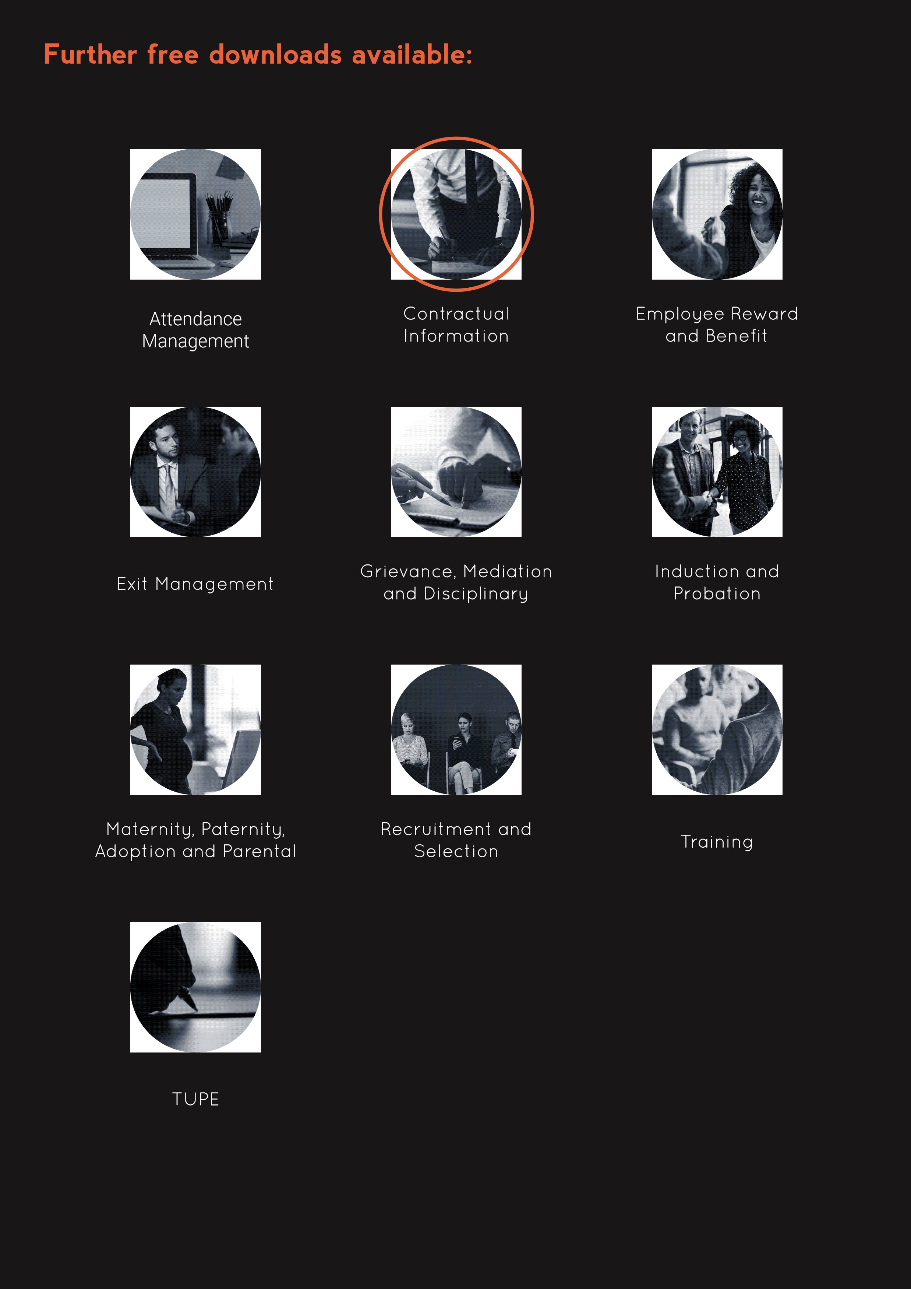

**www.questcover.com**

**01455 852028**