

**Induction and Probation**

**HR Guide**

**Induction and Probation – HR Guide**

# Introduction to the induction process

Planning an induction process for new employees is designed to ensure that the new employees settle into their employment easily to enable them to become effective as soon as possible. According to research, effective induction processes encourage closer identification with the employers and also assists to reduce employee turnover.

Most employers will have an induction programme but to ensure that it is working well it is useful to have a review of it with those employees who have passed through the process and have been in their jobs for a reasonable period of time. An effective induction programme should be applied to new recruits as well as employees moving from one job to another.

# Elements to include in an induction programme

A typical checklist of elements to include in an induction programme is:

1. The greeting of new employees – the new employee should have someone designated to meet them on arrival, to carry out the necessary personal information checks and to put in place any necessary security arrangements.
2. Information – the new employee should be given information about the company including an overview of the company’s structure, history, products, services and other aspects of the business.
3. The job – in terms of its content, how the department fits into the company as a whole, the expected key performance indicators, how these are evaluated and an explanation of the employee’s work colleagues including the line of reporting.
4. The main terms and conditions of employment – a Written Statement of the Main Terms and Conditions of Employment must be issued to new staff during the induction process to include the fundamental elements of the employment relationship i.e. pay, hours of work, holiday, sickness and notice of termination.
5. Company rules – an Employee Handbook is normally developed by professional organisations and the rules, policies and procedures within this document should be thoroughly explained to the new employee.
6. Security – in relation to access to the workplace, passwords, document authorisations etc.
7. Health and safety – giving the employees skills and knowledge needed to do their job safely. This will include any risk assessments for employees who describe any physical or other issues which will affect their ability to do the job in a particular way.
8. Data protection – an explanation of the information and documents kept in relation to the new employee should be explained.
9. Training and development – should include an explanation of any performance appraisal systems in place. Employers should assess whether the new employee needs any short/medium/long term training for them to successfully perform their job to the highest level.
10. Employee benefits and facilities – will include information on any company benefits, such as private medical insurance, death in service benefit etc.
11. Employee representation – to include any information on any Trade Union recognition or membership procedures that are in place.
12. Layout of the workplace – to include a tour of the offices and an assimilation of the facilities within the building.

On some occasions employees will have particular requirements especially if they are school leavers, female employees returning after maternity leave, someone moving to a completely new position, employees who are disabled or employees returning to work after a long period of unemployment. In such cases specific attention should be paid within the induction process to the individual requirements of these categories of employee.

# Introduction to the probation process

In order to assess your employee’s performance and conduct a probation period is usually taken during the early stages of employment, generally for three or six months.

It is perfectly normal for employers to recruit new employees subject to the satisfactory completion of a probationary period. If there is a probationary period in place, the employer should make clear the duration of the period in question, whether there are any specific terms and conditions of employment which will or will not apply during the probationary period and whether terms are different during the probationary period than after the probationary period.

Employees under a probationary period have the same rights as other employees and accrue continuous employment in the same way as if no probationary period existed. A Written Statement of the Main Terms and Conditions of Employment must be issued on or before their commencement date.

**What should be done when the probation period is over?**

Employers must monitor and assess work performance and conduct throughout and address the issues with the employee. On completion of the probationary period employers should formally review the probationary period with the member of staff. If the employee is deemed suitable this should be confirmed and the probationary period will therefore come to an end. If, however, there are continuing doubts over the employee’s suitability, the probationary period may be extended provided that employers have reserved the right to do so in writing within the original documentation issued to the employee. If the employer concludes that the employee has not reached the required standard then the employment can reasonably be terminated.

As in all the cases employers must have a designated fair reason to terminate the employment and must also act fairly in the dismissal of the employee. The key factor is for employers to be able to produce objective reasons to justify any dismissal either during or at the end of the probationary period.

# Data protection (GDPR)

Legislation exists to regulate the processing of information relating to individuals within their place of employment.

The data protection law provides employees with certain rights, in respect of data, which is held by their employer.

The Information Commissioner’s Office has wide enforcement powers and procedures in place, designed to ensure employers comply with the provisions of the law and also prevent breaches of the law by, described as ‘data controllers.’

Data controllers can only process personal data in accordance with the data protection principles and procedures laid down. In the workplace data protection relates to any data that employers might collect, and keep, relating to their workers. This can include both job applicants and employees, and all other associates of an employer who perform services for them.

Most of the normal day-to-day information that is utilised by an employer about a worker or employee is likely to fall within the scope of the legislation and the Code of Practice. Individuals about whom information is held are called data subjects.

They currently have the right to subject access, the right to prevent processing likely to cause damage or distress, the right to seek compensation if they suffer such damage and the right to take action to rectify, block, erase or destroy inaccurate data.

There are, therefore, regulations and procedures on collecting and keeping employment records, including sickness and absence records, equal opportunities monitoring and discipline, grievance and dismissal information.

In essence there is now extensive regulatory provision for all aspects of the storage and access to information held by employers about employees.

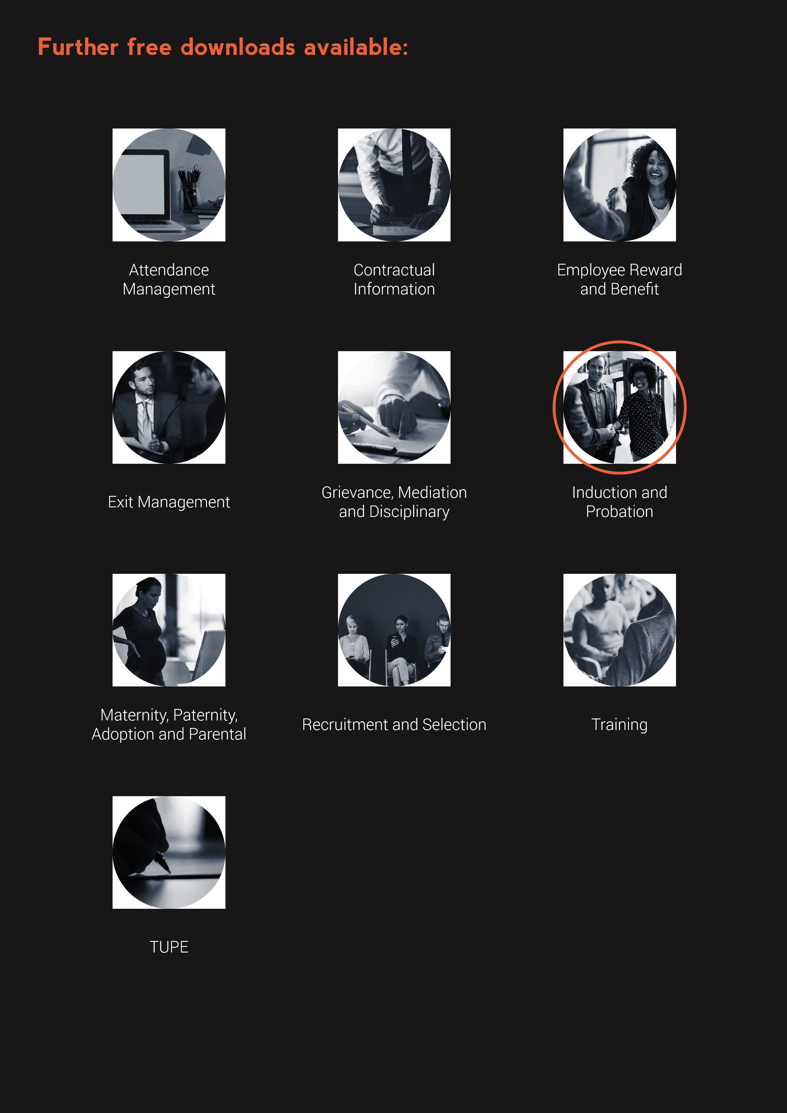

**www.questcover.com**

**01455 852028**