

**Maternity, Paternity, Adoption**

**& Parental**

**HR Guide**

**Maternity, Paternity, Adoption & Parental – HR Guide**

# Introduction

This guide covers a range of information which includes:

* Maternity rights
* Paternity rights
* Adoption rights
* Parental rights

**See below for more detail**

# Maternity rights

Employees are able to be absent from work for the duration of a period of Ordinary Maternity Leave of 26 weeks and a further period of Additional Maternity Leave period of 26 weeks. These two periods combined comprise the Statutory Maternity Leave entitlement of 52 weeks in total.

During Statutory Maternity Leave, employees who satisfy the qualifying requirements are entitled to receive an amount of Statutory Maternity Pay, the level of which is adjusted each year by the Government. Currently, Statutory Maternity Pay is payable for up to 39 weeks. The first six weeks are payable at 90% of average gross weekly earnings, with the remaining 33 weeks being paid at the lesser of 90% of the average gross weekly earning or the standard SMP rate in force.

Employees are able to choose the date on which their Ordinary Maternity Leave period starts, provided the start date falls within 11 weeks of the expected week of childbirth. There are however obligations upon an employee to notify the employer in advance about her pregnancy and related matters in order to qualify for the leave.

Statutory Maternity Leave is applicable to employees regardless of length of service, level of pay or hours worked.

Eligible parents of children born or matched for adoption are entitled to share the care of their child during the first year after their birth or adoption. Parents have the option of choosing to share the maternity leave period. Mothers still need take the initial compulsory two or four weeks following the birth of the child but can then split the remaining weeks of Shared Parental Leave. SMP, if applicable, is still paid for 39 weeks.

‘Keeping in Touch’ Days are also an option for employees during their maternity leave period. The provisions in relation to Keeping in Touch Days are contained in the Maternity and Parental Leave (Amendment) Regulations 2006.

An employee on Maternity or Adoption Leave can agree with her employer to work for up to ten days during the Statutory Maternity Leave period of up to 52 weeks.

Keeping in touch days still apply to those parents that choose to take shared parental leave.

The employee cannot however be forced to work. Any pressure placed on an employee to work would amount to a detriment, entitling the employee to bring a claim under the Employment Rights Act 1996. Equally, the employer does not have to offer ‘Keeping in Touch’ days to the employee.

The employee would be entitled to be paid at their normal rate of pay during these days and would not lose their other maternity benefits. Any period of work would amount to a day’s work for the purposes of a ‘Keeping in Touch’ day but the primary purpose of these days is for the training and updating of employees.

A return to do some work on one of these days, does not bring the Maternity Leave to an end nor can the Maternity Leave period be extended by the number of days used.

# Paternity rights

Paternity Leave was introduced through the Employment Act 2002. Subject to certain qualifying requirements relevant employees are entitled to one or two weeks’ leave from work when the baby is born. Employees can also qualify for paternity leave when they adopt a child.

To qualify for Paternity Leave, employees need to expect to have responsibility for the child’s upbringing, be the biological father or mother’s partner (this can include same sex partner) and have 26 weeks continuous service at the 15th week before the baby is due.

Employees are able to take either one or two consecutive weeks of leave. There is no legal right to take leave in individual days or two separate weeks. Leave has to be taken within eight weeks of the actual date of birth or adoption.

Employees who earn at least the lower earnings limit are entitled to receive Statutory Paternity Pay (SPP) for the weeks taken as leave.

This is paid at a flat rate or at 90% of average weekly earnings if this is less than the flat rate.

The provision also applies to circumstances where a child is adopted

# Parental rights

A person will be entitled to Parental Leave if they have been continuously employed by the employer for at least one year and have, or expect to have parental responsibility for a child under 18 years.

Leave cannot be taken after the child’s 18th birthday. There are also limits on the amount of leave to be taken in total and also the amount of leave to be taken in an individual year. There are also restrictions on the blocks of time that the parent can take as leave. Employees can complain to an Employment Tribunal about any aspect of their employer’s refusal to grant parental leave.

Currently there is no statutory entitlement to payment for any period of parental leave.

# Adoption rights

Since 1st April 2007 adoption leave and pay entitlements in relation to an adoption from within the United Kingdom, are as follows. Different rules apply where the adoption is from outside the United Kingdom.

To qualify for adoption leave where the adoption is within the United Kingdom, the employee:

* Must have been matched with a child
* Have notified the agency that the child should be placed with them and agree the date
* Notify their employer of when they want to take their adoption leave no more than seven days after they have been notified that they have been matched with a child

Eligible employees can take up to 52 weeks leave which is made up of 26 weeks Ordinary Adoption Leave and 26 weeks Additional Adoption Leave.

For those employees who qualify for Statutory Adoption Pay they will be entitled to receive Statutory Adoption Pay for up to 39 weeks.

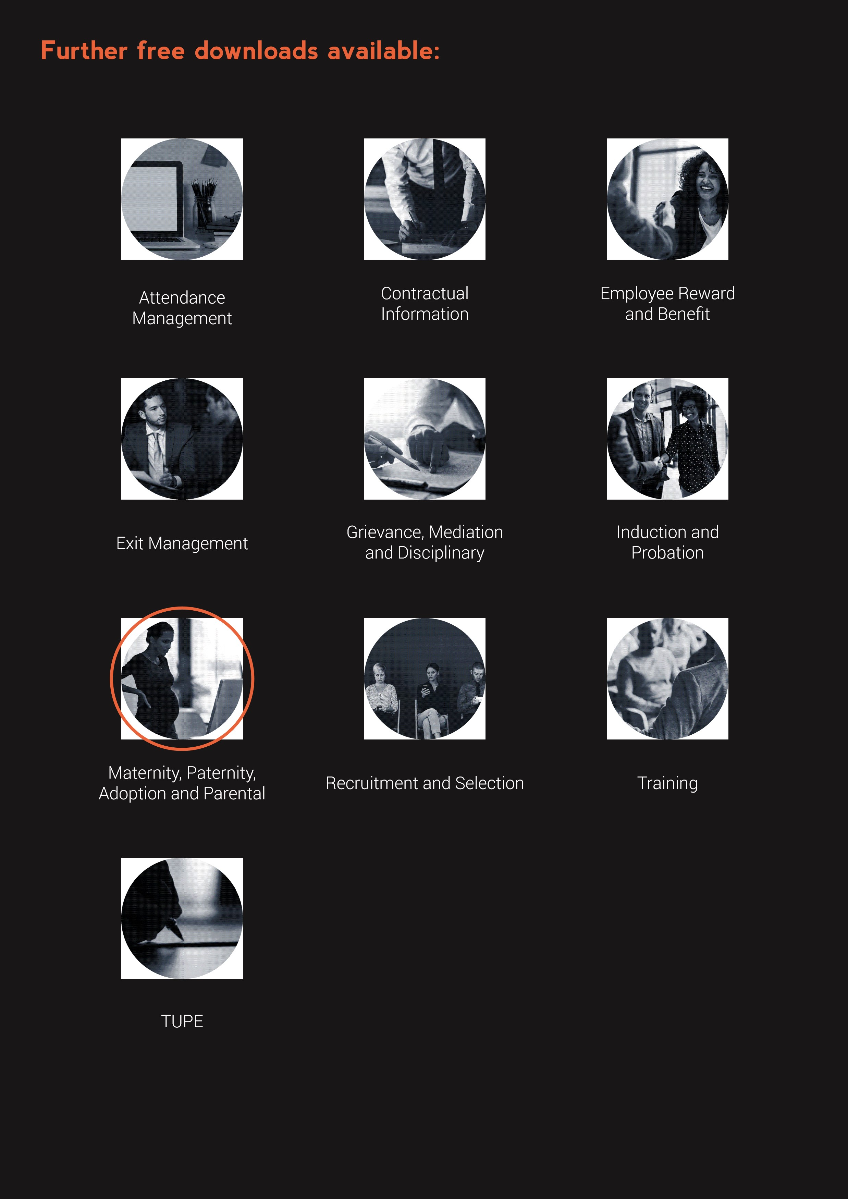

**www.questcover.com**

**01455 852028**