

**Recruitment and Selection**

**HR Guide**

**Recruitment and Selection – HR Guide**

# Introduction to recruitment and selection

Getting your recruitment and selection process right is not easy and on average it costs up to £10,000 to recruit a new employee; getting it wrong can cost a business more than three times that amount. Prior to employment, employees still attract the protection of the law even before an offer of employment is made to them. The right process, limits not only the legal challenges but also it helps to minimise the mistakes often made in recruitment.

Taking each individual element of the recruitment and selection process and ensuring that thought goes into each area, ideally resulting in a recruitment plan, assists in ensuring that the process results in the vacancy being offered to the most suitable candidate.

# The recruitment and selection process

In brief this should take the lines of:

* Position identified (full time, part time, temporary)
* Type of worker required (employed, self-employed, apprentice)
* Advertising
* Job offer

**See below for more detail:**

## Pre-recruitment

Pre-recruitment is when the business has identified that a position needs to be filled. It is at this stage that the business needs to identify the type of worker to fill that position. Whether the position calls for cover on a short term basis or a person who is employed or self-employed on a full time basis.

## Advertising jobs

Employers, where appropriate, should ensure that vacancies are advertised internally and that any employees on maternity leave are made aware of vacancies within the organisation.

All advertisement or recruitment documents issued should almost always avoid the inclusion of job requirements, which relate to the successful applicant's age, race, sex, disability, religion or Trade Union affiliation. Specifically for Northern Ireland, the Fair Employment Legislation should also be considered.

## Agency workers

Agency workers are often used to help businesses on a short-term basis, either to act as cover for absent staff or to cope with unexpected increases in workloads. A key question in any such relationship concerns the employment status of agency workers.

## Apprenticeships

Apprenticeships combine practical training in a job with study, whilst gaining job-specific skills and working towards a related qualification. An apprenticeship can take a number of years to complete depending on the level of qualification and is ideal for those employers who wish to build and retain new talent within their organisation.

## Apprenticeship levy

Employers with a pay bill of over £3 million each year pay the 0.5% levy to fund their own apprenticeships. Employers with pay bills below this amount do not pay the levy but may benefit from funding support by the government for the cost of apprenticeship training and end point assessments. There are other incentives for employers taking on apprentices, full details available in the Gov.UK website.

## Employed or self-employed

The distinction between a person who is employed and another who is self-employed is usually sufficiently clear. However, when an individual is trying to enforce their legal rights, such as a person who claims that he/she has been unfairly dismissed, it is not uncommon for employers to argue that the person is actually self-employed and therefore not entitled to make a claim. Such cases are often made more difficult for the alleged employer where a written contract exists but the parties disagree as to its effect.

If a person who is described as being self-employed is found by a Tribunal in reality to be an employee or a worker, the main consequences that arise fall upon the employer. Employers may be found liable to account for the PAYE and National Insurance Contributions that should have been paid over the course of the employment as well a potential compensatory award against them by the Tribunal.

The basic tests that have been applied by Employment Tribunals to determine whether a person is employed or self-employed relate to two main headings. For an employment relationship to exist, there must be:

* Mutuality of obligation, sufficient control and work that is personally performed, and
* The worker must not be in business on their own account.

## Employees and workers

An employee is defined as an individual who has entered into or who works under a Contract of Employment. Arising from this status as an employee, a large number of statutory rights have developed. These are:

* Continuity of employment on the transfer of an undertaking
* Equality for fixed term employees
* Guarantee payments
* Itemised pay statements
* Maternity, adoption and paternity rights
* Minimum periods of notice
* Not to suffer unlawful deductions from wages
* Parental rights
* Medical suspension payments
* Redundancy rights
* Flexible working
* Statutory sick pay
* Time off during working hours
* Unfair dismissal protection
* Written statement of the main terms and conditions of employment
* Written statement of the reasons for dismissal

## Right to work

An employer can only employ an individual who has permission to live and work in the UK. Employers must ensure before the employment commences, the correct right to work checks are complete and a statutory excuse achieved.

## Discrimination

The scope of discrimination legislation in force covers job applicants and workers (including workers under a contract for apprenticeship) and in certain circumstances former workers and workers who work wholly or partly in Great Britain. Volunteers working under a noncontractual volunteer agreement will normally not be covered unless they perform their services under a contractual arrangement. The legislation covers workers before, during and after employment.

## Equality and diversity

Equality and diversity promotes equality, giving individuals the opportunity to achieve their potential free from discrimination. This includes:

* Race
* Religion and belief
* Disability
* Age

## Offer of employment

There is a statutory requirement to issue a statement of the main terms and conditions of employment. Employers must remember that a failure to issue a statement of main terms and conditions of employment, within the first day of employment, can result in an employee making a claim to a Tribunal. The Tribunal may award a sum of two or four weeks pay which is subject to the statutory cap on a weeks pay where the employee’s claim succeeds. Before a contract becomes legally binding, it needs to contain four elements:

* An offer
* An acceptance
* Consideration i.e. the mutual obligations of each party towards the other
* An intention to create a legally binding contract

In circumstances where an employee is offered, and has accepted a job, employers may have some liability if they withdraw the job offer prior to the commencement of the employment. Offers and acceptances of employment can also be verbal although it is obviously advisable that all such communications are confirmed in writing.Employers may be bound by any verbal or written commitments, given at interview or offer stage and great care should therefore be taken in relation to the communications given to employees, or prospective employees, at this stage.

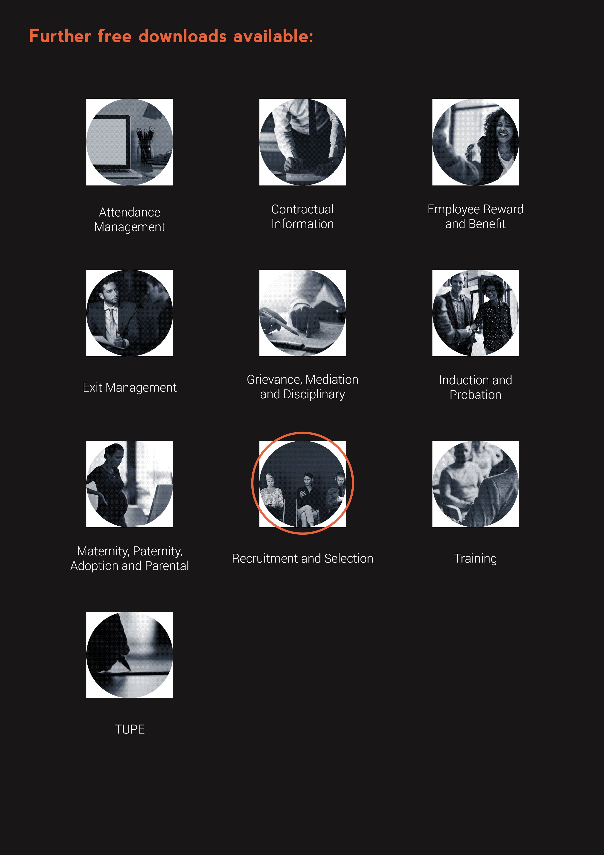

**www.questcover.com**

**01455 852028**